PHP ASSIGNMENT

**TOPIC – SQL TASK 2**

TABLE – SALES PERSON

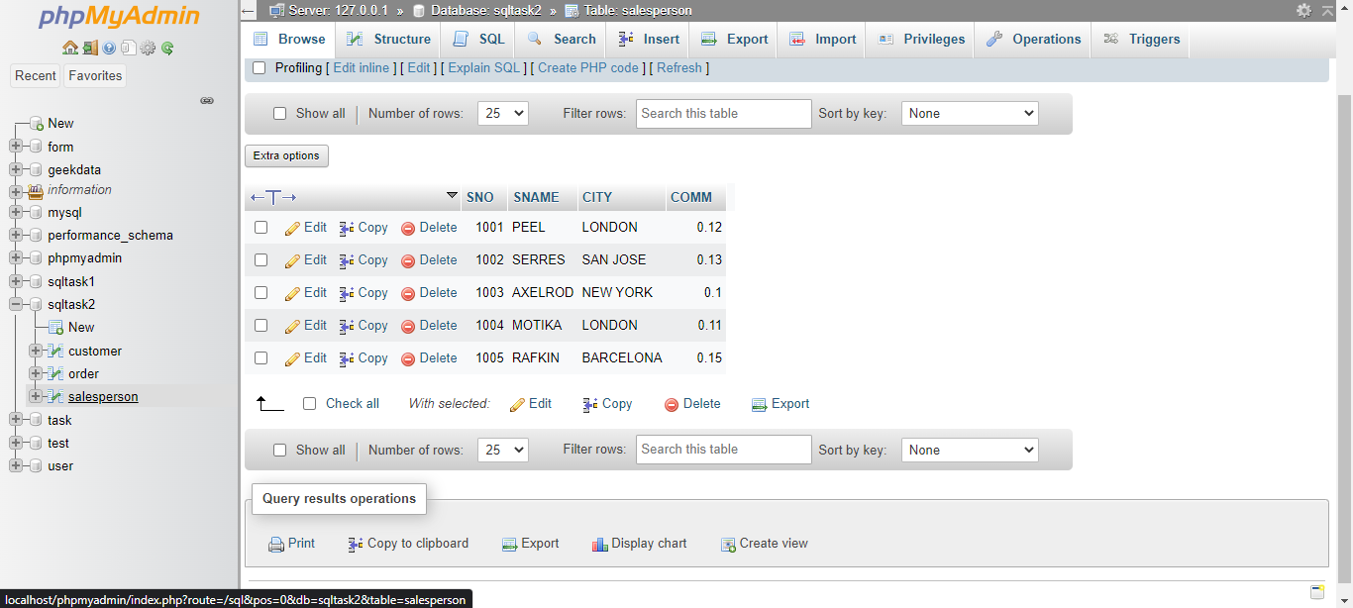

TABLE – CUSTOMER

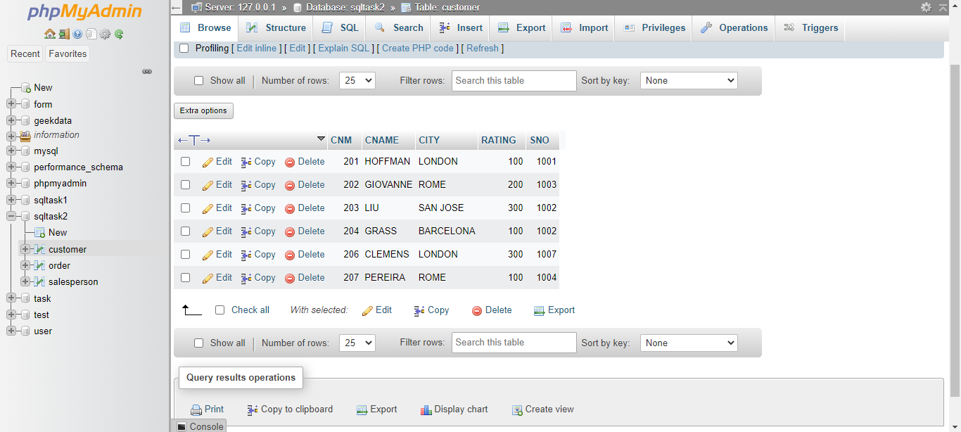

TABLE – ORDER

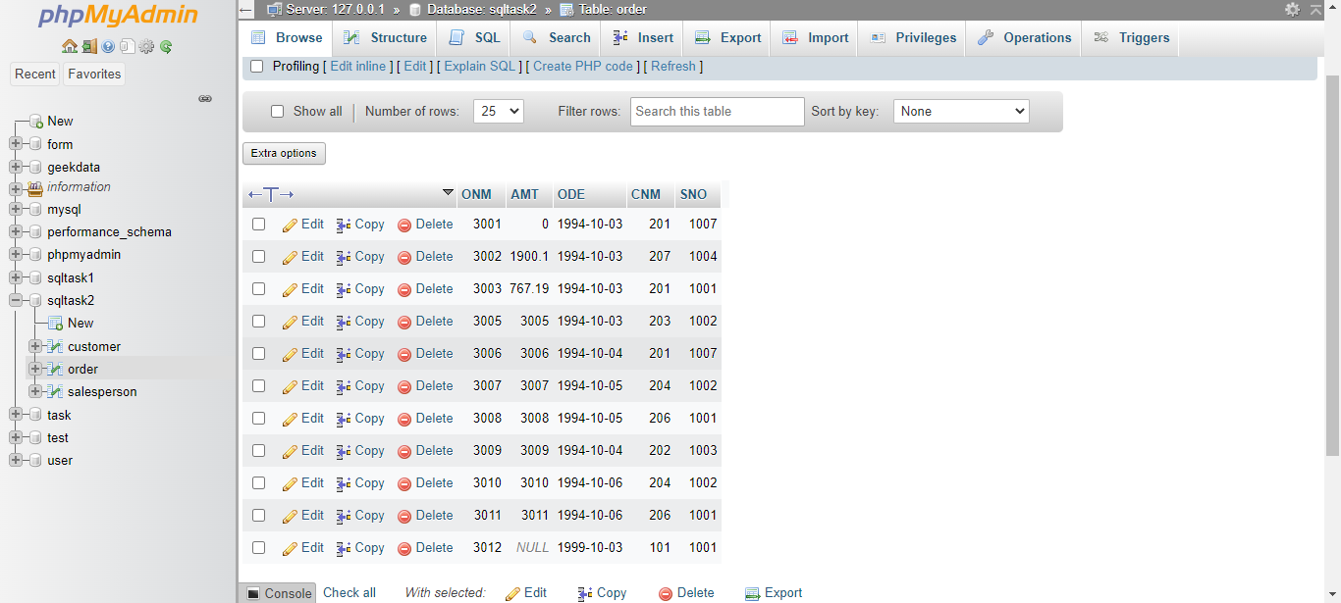

1. All orders for more than $1000.

Ans: - SELECT * FROM `order`WHERE AMT>1000;

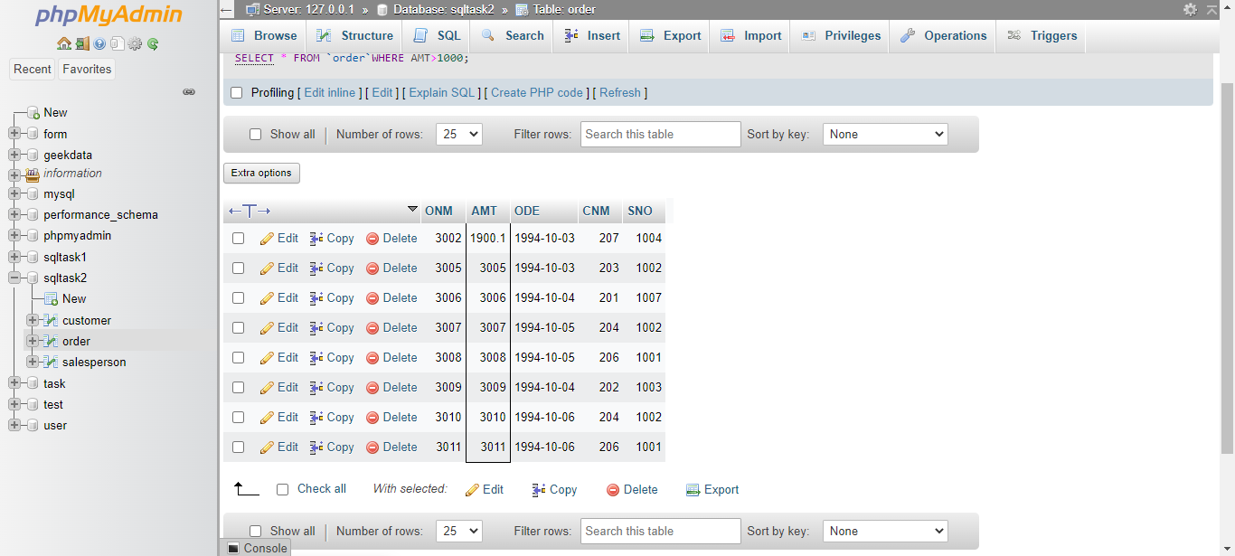

1. Names and cities of all salespeople in London with commission above 0.10.

Ans: - Select SNAME, CITY FROM salesperson WHERE comm > 0.10 and CITY= 'LONDON';

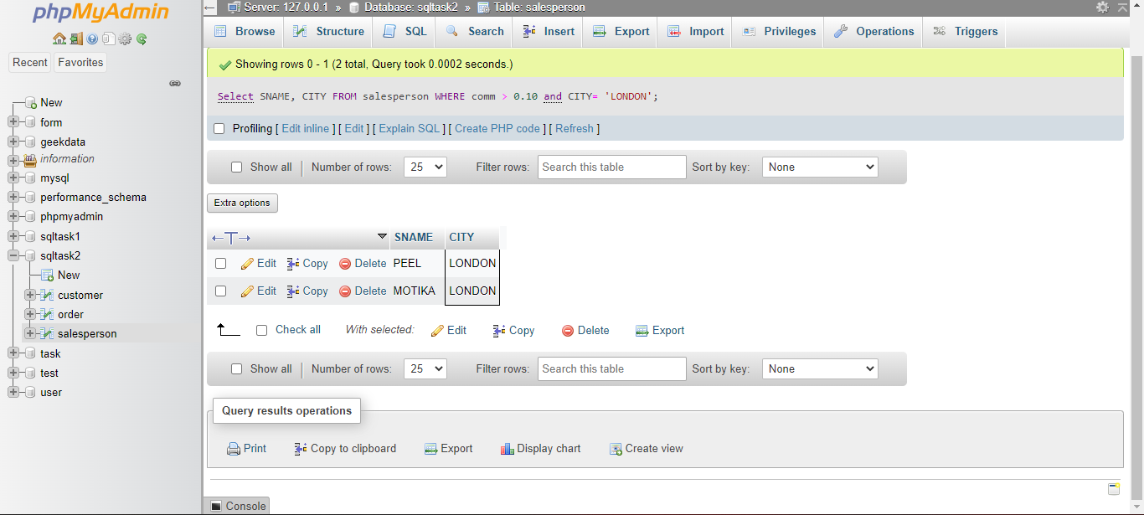

1. All salespeople either in Barcelona or in London.

Ans: - SELECT SNAME,CITY FROM salesperson WHERE CITY IN('BARCELONA','LONDON');

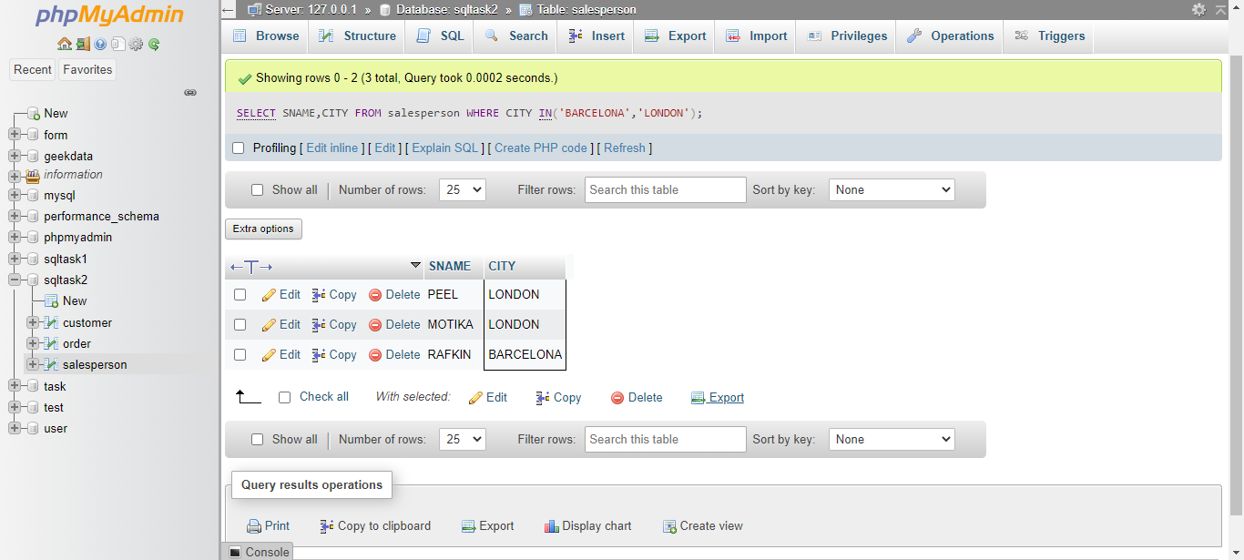

1. All salespeople with commission between 0.10 and 0.12. (Boundary values should be excluded).

Ans: - SELECT SNAME,COMM FROM salesperson WHERE COMM > 0.10 AND COMM < 0.12;

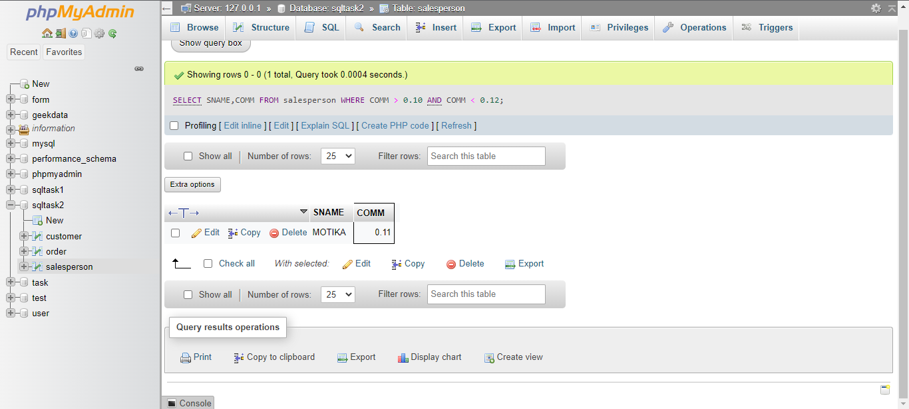

1. All customers with NULL values in city column.

Ans: - SELECT CNAME FROM customer WHERE CITY IS NULL;

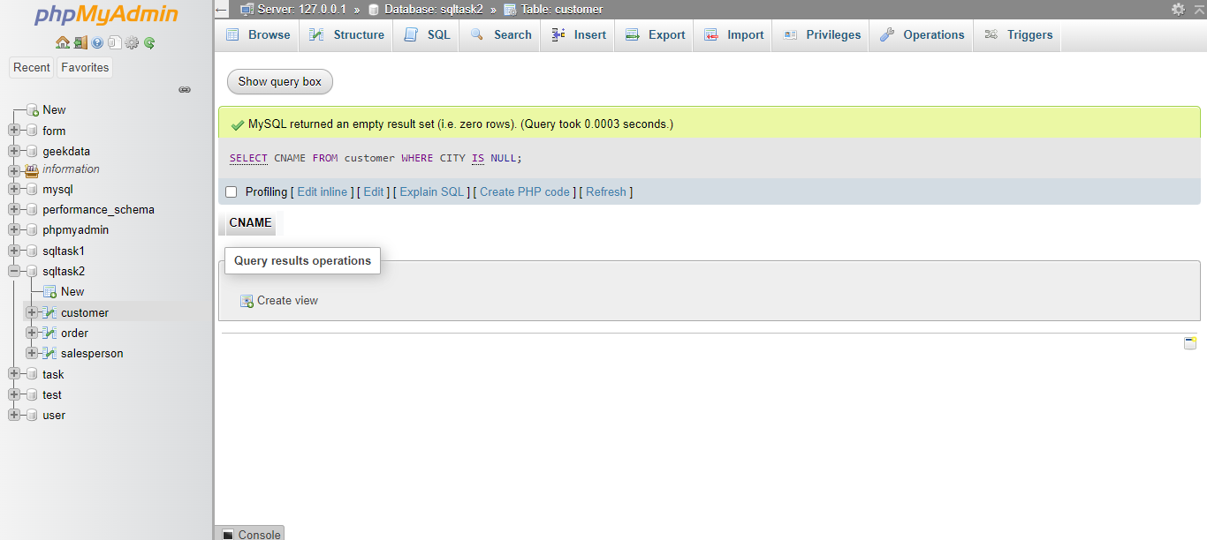

1. All orders taken on Oct 3Rd and Oct 4th 1994

Ans: - SELECT * FROM `order` WHERE ODE IN ('1994-10-03','1994-10-04');

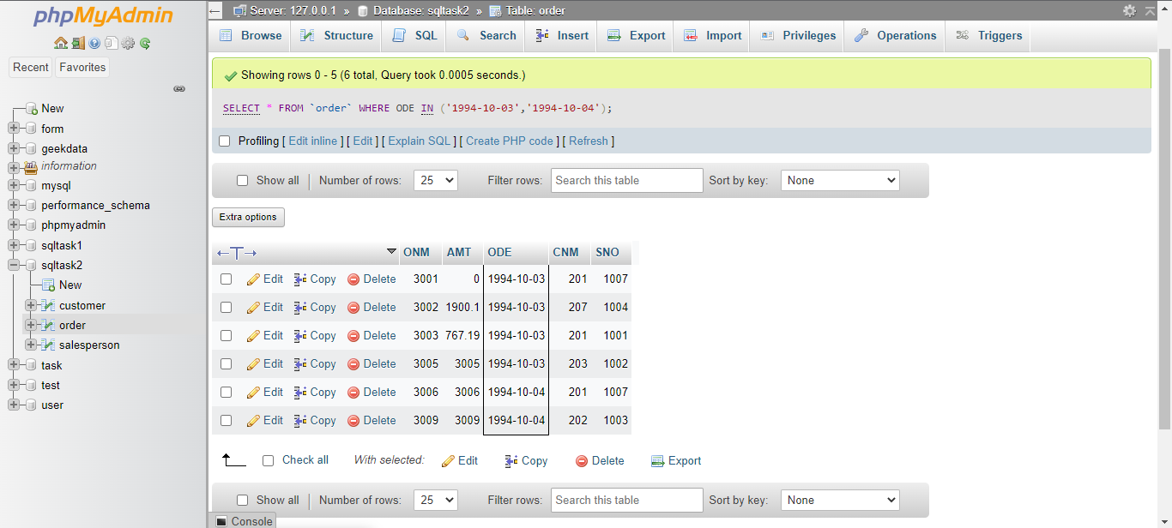

1. All customers serviced by peel or Motika.

Ans: - SELECT CNAME FROM customer WHERE SNO IN (1001,1004);

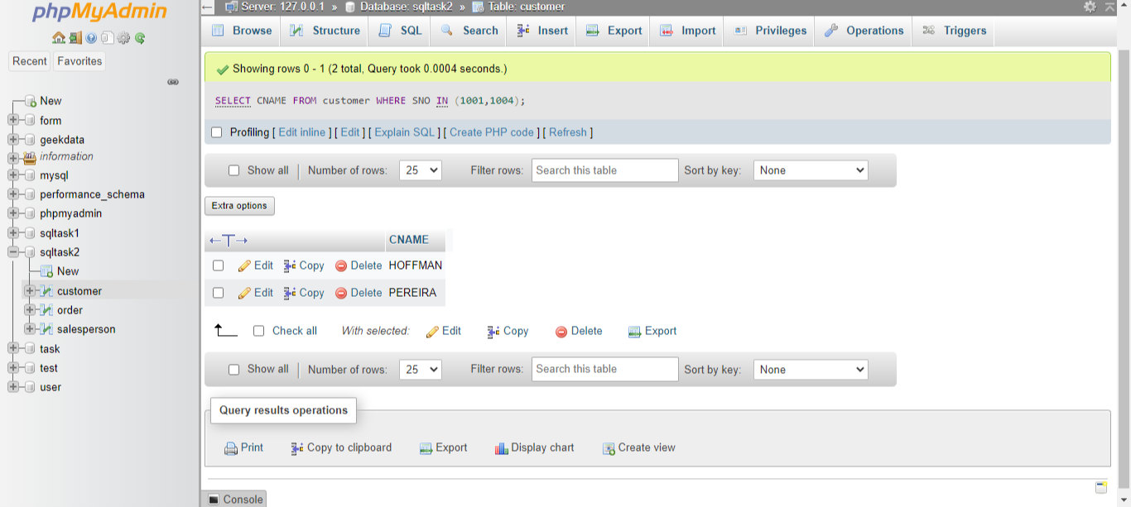

1. All customers whose names begin with a letter from A to B

Ans: - SELECT CNAME FROM customer WHERE CNAME LIKE 'A%' OR CITY LIKE 'B%';

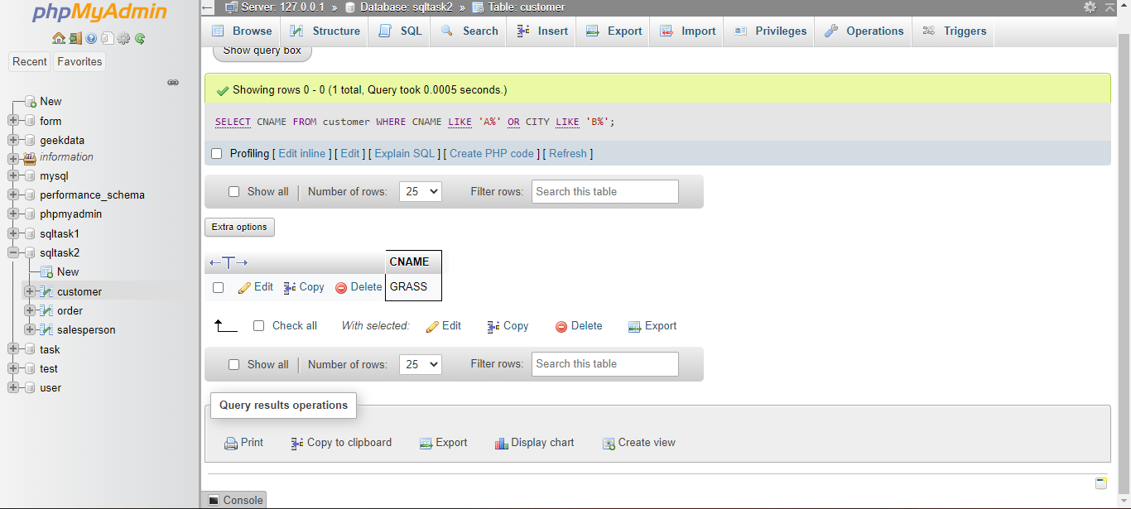

1. All customers excluding those with rating <= 100 unless they are located in Rome.  
   Ans: - SELECT CNAME FROM customer WHERE RATING <=100 OR CITY ='ROME';

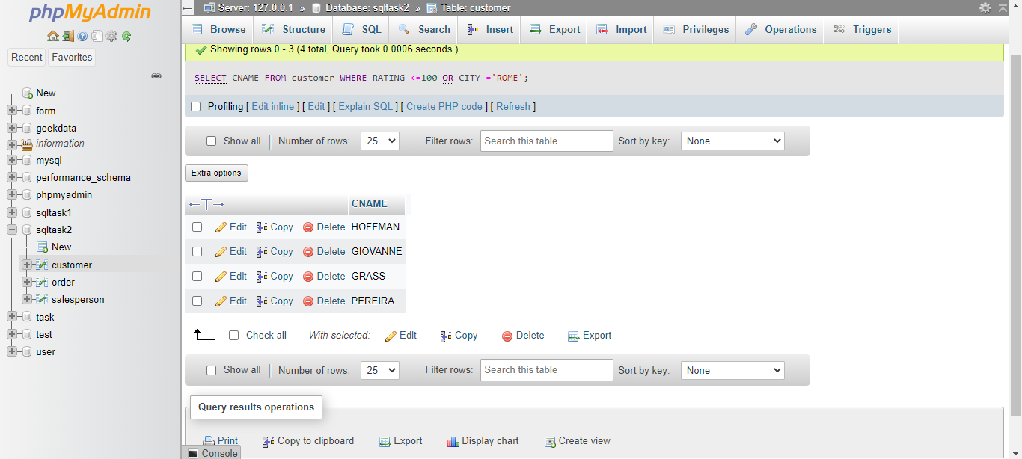

1. All orders except those with 0 or NULL value in amt field.

Ans: - SELECT * FROM `order` WHERE AMT != 'NULL';

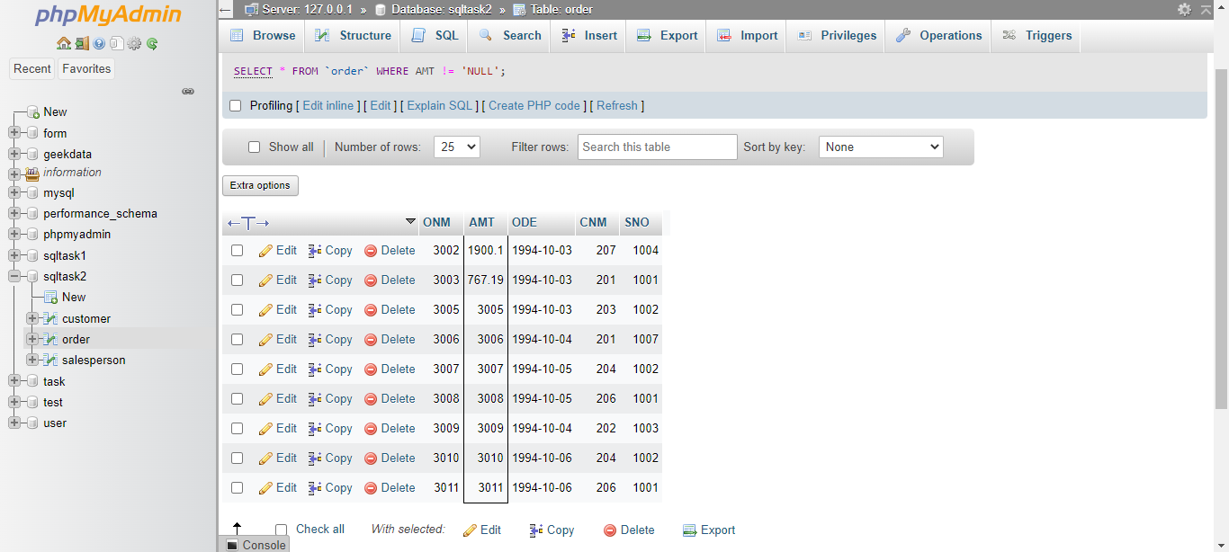

1. Count the number of salespeople currently listing orders in the order table.

Ans: - SELECT COUNT(DISTINCT SNO) FROM `order` WHERE 1;

